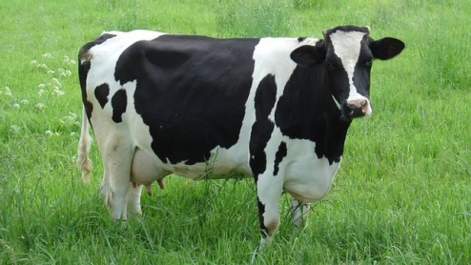
DAIRY PRODUCTS

Introduction to Dairy
Dairy is milk, yogurt, cheese etc. Yogurt is often included on healthy food list. Dairy comes from cows, goat and sheep. Cheese is produced throughout the world.

History of Dairy
In 1856 French scientist Louis Pastcer discovered that heating liquids to high temperatures kill bacteria. This process is called pasteurization and it protects the purity and flavours of milk. The best sources of calcium are milk yogurt and cheese. About 72% of calcium in the U.S. food supplys comes from dairy foods.

Facts about dairy:
U.S. cows give an average of 6½ gallons of milk per day. That’s over 100 glasses of milk –enough for 33 children to have 3 glasses each. Semi-skimmed milk has 1% fat. Cheese can be high in fat and salt. People crave for cheese more than any other food.

