Hedgehogs

Hedgehogs got their names because they live under hedges and they snuffle like a hog when they hunt. They are nocturnal animals. There are 7 different species of hedgehog and the most common is the African Pygmy Hedgehog.
Hedgehogs are very bristly. They have seven thousand bristles on their back. They use these to protect them from falls and from their enemies. Hedgehogs can be many different colours.
Hedgehogs can be found all over the world. They live in the wild but can also be kept as pets. They like to live on their own.
Hedgehogs use 2 muscles to curl up into a ball. They need lots of exercise.
Hedgehogs can have five to seven babies at a time. They live between three and five years. They can get wobbly hedgehog syndrome as they get older. They are nice little animals.
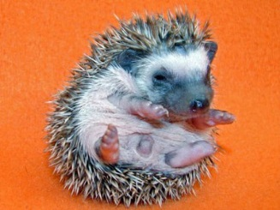
By Jack Jones & Lucy Gallagher

