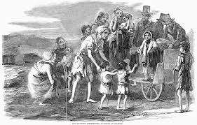
Irish Famine.

Introduction
The Irish potato famine started in September in 1845 and went on until 1852, it killed over a million men, women and children in Ireland and caused another million to flee the country. Before the famine, all the families in Ireland relied on potatoes and one year the potatoes failed from something called ‘potato blight’. Many of the potatoes were found to have gone black and rotten and their leaves had withered.
Catastrophe for the Poor
In the harvest of 1845, between one-third and half of the potato crop was destroyed by the strange disease. It was one of the greatest catastrophes of the nineteenth century. In Ireland, one in four people died or emigrated. In Ireland, most of the best land was used for cattle, poor farmers were left to grow potatoes, and not much else. To make matters worse, there were more mouths to feed because the population was growing. For help, starving families turned to the Church, the workhouses and landlords, churches could not feed so many hungry people. Nor could workhouses, which became so overcrowded many people died from diseases.
Coffin ships
Many of the Irish people emigrated to America; their form of transport was using coffin ships. Some 'Coffin Ships' took 3 months to cross the ocean to North America. Migrant ships were called 'Coffin Ships', because so many people died. It's thought that in 1846/1847 20,000 people died in migrant ships sailing to Canada alone! To escape famine at home, many poor Irish emigrated to America and Canada. They went in ships. Charities paid for tickets for some poor families.
Conclusion
Potato blight still hits the potatoes now but we don’t rely on potatoes like they did in the 19th century. We still use potatoes but there are now many solutions for treating potato blight. We lost 40% of the population in the famine. Churches and landlords helped and bought the ticket for some poor family for the coffin ship.

