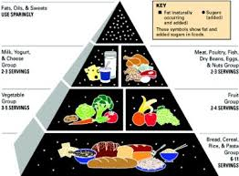
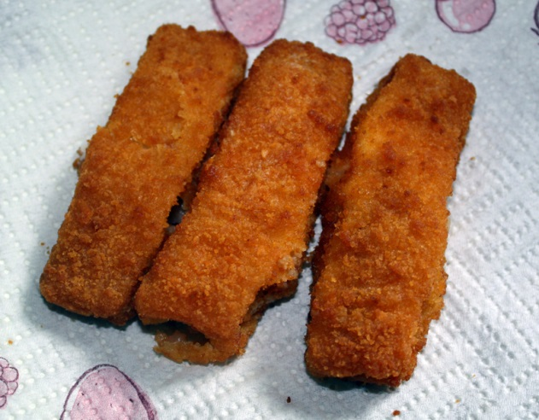
What people ate in the 1960s
Meat and two veg was the staple diet for most families in the 1960s.

Drinks
Bars opened in 1954 and were selling ham burgers and drinks. Parents had no tea or coffee in the UK in 1960s.

Dinner
People in the 1960s ate cheese on toast for dinner. They ate apples and bananas for dinner. Some people had bold egg for breakfast and dinner.

They used to eat raw meat in the 1960s. They had bacon for breakfast. No people assumed food safety completely. Monday they ate scrambled egg/cold meat and salad and welsh rarebit. Walsh rarebit is stew and Scottish haggis.

