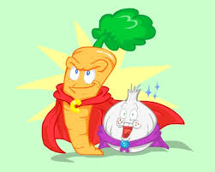
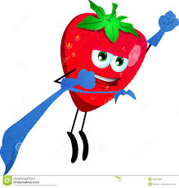
Fruits and Veggies
Introduction:
Fruits and vegetables are an important part of a healthy diet. This healthy food provides all of the nutrients you need to be healthy. Eat plenty every day. Fruit and veg is a crop that grows on trees or comes from the ground.
Nutrients and Sugars:
When you cook veg you can take some, or even all, of their nutrients out. They all have sugars but the sugars are all natural. A diet rich in fruits and veg can lower blood pressure and reduce the risk of heart disease and stroke and can even prevent some types of cancer.
Vegetables:
Black eyed peas come from America. These beans are often called black eyed beans or cow bean. They have a little black dot on the side of them and this is where they were attached to their pod. It is a bit like a belly button and can be put into a salad. Carrots are a veg that grow underground. Harriot beans are cooked in tomato sauce and make baked beans.
Fruit:
Fruit are a healthy snack for you and are tasty too. Peaches are a fruit that grow on trees in dry sunny countries. Raisins are dried grapes and grapes also make wine! Pumpkin is a big fruit and it takes 6 months to grow.
Conclusion:
There are no limits on the quantities of tasty fruits and veg you can enjoy. But don’t load them with butter. Always eat at least 5 fruits and vegetables every day if not more.

