Protein
Proteins contain carbon, oxygen, hydrogen, nitrogen and some types even have sulphur. It is made up of amino acids which helps structure cells in your body. The human body contains over 100,000 different types of protein. Protein helps your hair and facial hair grow. You should intake 75 grams of protein each day, but if you intake too much protein you have a chance of dying.
What foods have the most protein:
Eggs have the most amount of protein than any other food, but meat has a fair amount of protein as well.
+ milk= 8 grams protein per cup.
+tuna= 25 grams protein per 3 oz serving.
+green peas= 7 grams protein per 1 cup serving.
Fun facts:
Some insects contain high levels of protein. 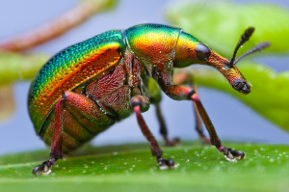

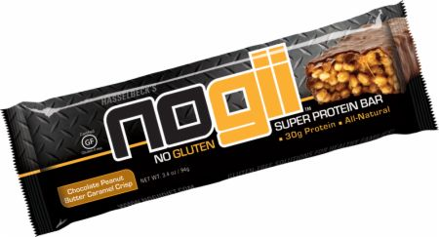
Some protein bars have over 400 calories.

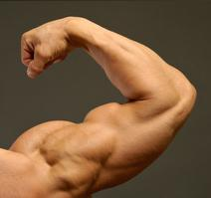
Protein helps you build muscles.

