Squirrels

Squirrels are members of the rodent family. They live for 4 to 5 years. They all over the world except for Australia and Antartica. There are 500 different species of squirrels including ground squirrels and flying squirrels.
Squirrels are small animals with short fur and a long bushy tail. They have long claws and teeth. Their teeth grow 15cm every year.
Squirrels can climb trees easily. They eat mostly nuts, berries and flowers. They may eat insects. They bury their food in the ground and dig it up later to eat. Some squirrels have pouches in their cheeks to carry food.
Their enemies are cats, foxes, eagles, skunks and owls. They scamper up trees to get away from their enemies.
Squirrels are not very clever and lots of them get run over every year.
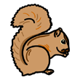 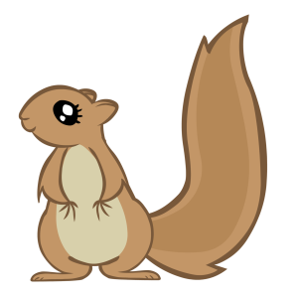 By Lucy & Jack

