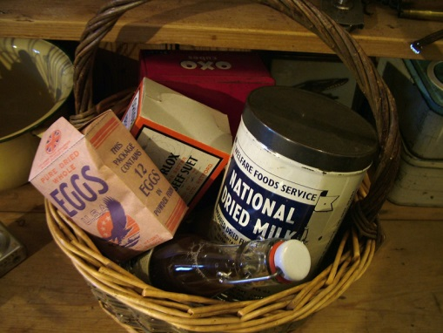
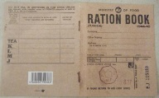
WW2 Diet

The Emergency
World War II was called The Emergency because we were short of food because Europe was fighting in the war. Food was scarce because supplies usually came to Ireland and Great Britain by ship and many supply ships were sunk by German U-boats, which were submarines.

Rationing
During the Emergency, as the Second World War was known in Ireland, every individual was issued with a ration book, and rationing continued long after the end of the war. Commodities rationed during the war included tobacco, tea, sugar, flour, soap and clothing. These items were scarce as they needed to be imported, but unlike the United Kingdom, eggs and meat were not rationed as people had their own animals to provide these necessities.

Ration Books
Inside each ration book were several pages of instructions in both Irish and English followed by pages of numbered squares, either marked by the product name or containing a letter to be used for different purchases. Space was also provided for keeping details of when, where and what was purchased. Food was scarce it was rationed. This meant that you could only buy a certain amount of rationed food per week. Everyone had a ration book with coupons. You gave the ration book to the shopkeeper and then you got your food for the week. Foods that were rationed were bacon, lard, butter, tea, sugar, and coffee.

During the Second World War many food and drink items were in short supply. This was because much of the food came to Britain on ships from abroad. Around 70% of food in Britain was being imported. At this time, the ships of the Merchant and Royal Navies were being sunk by the enemy ships and submarines (called U-boats) of Germany.

